CS 255 System Design Document Template

UML Diagrams

UML Use Case Diagram
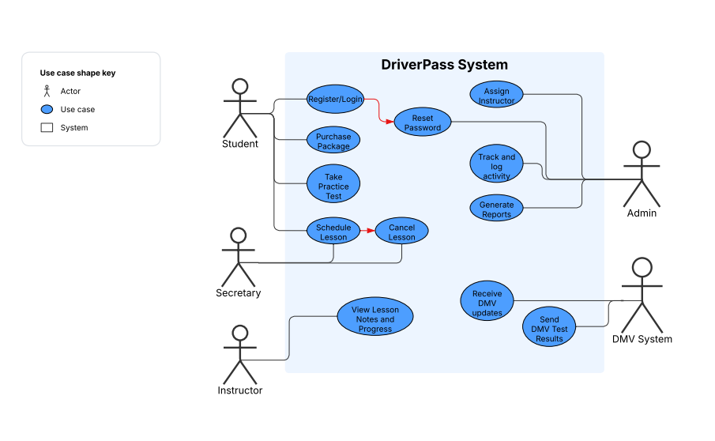

UML Activity Diagrams
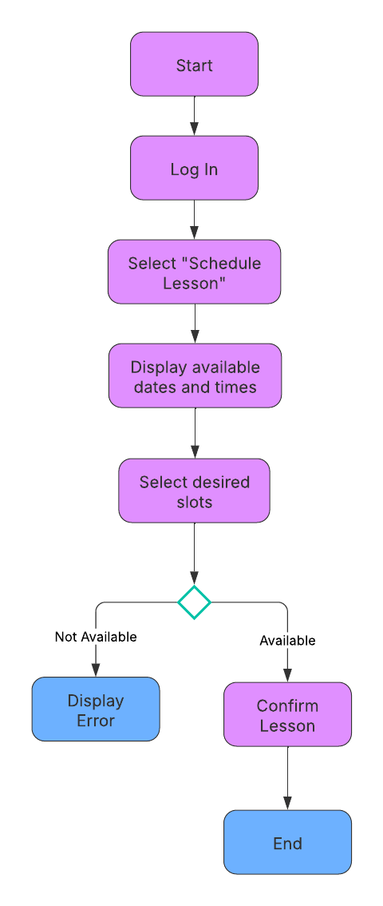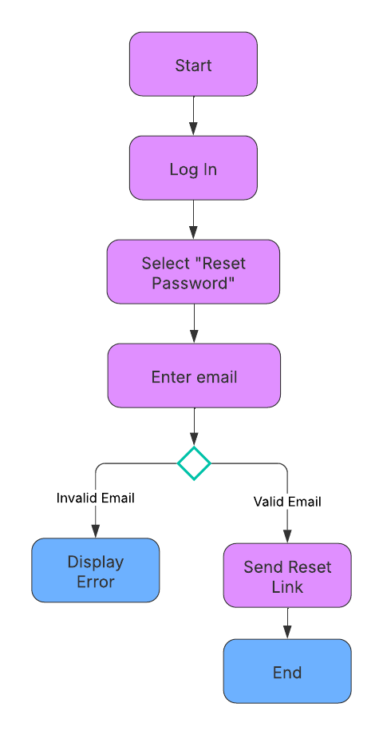

UML Sequence Diagram
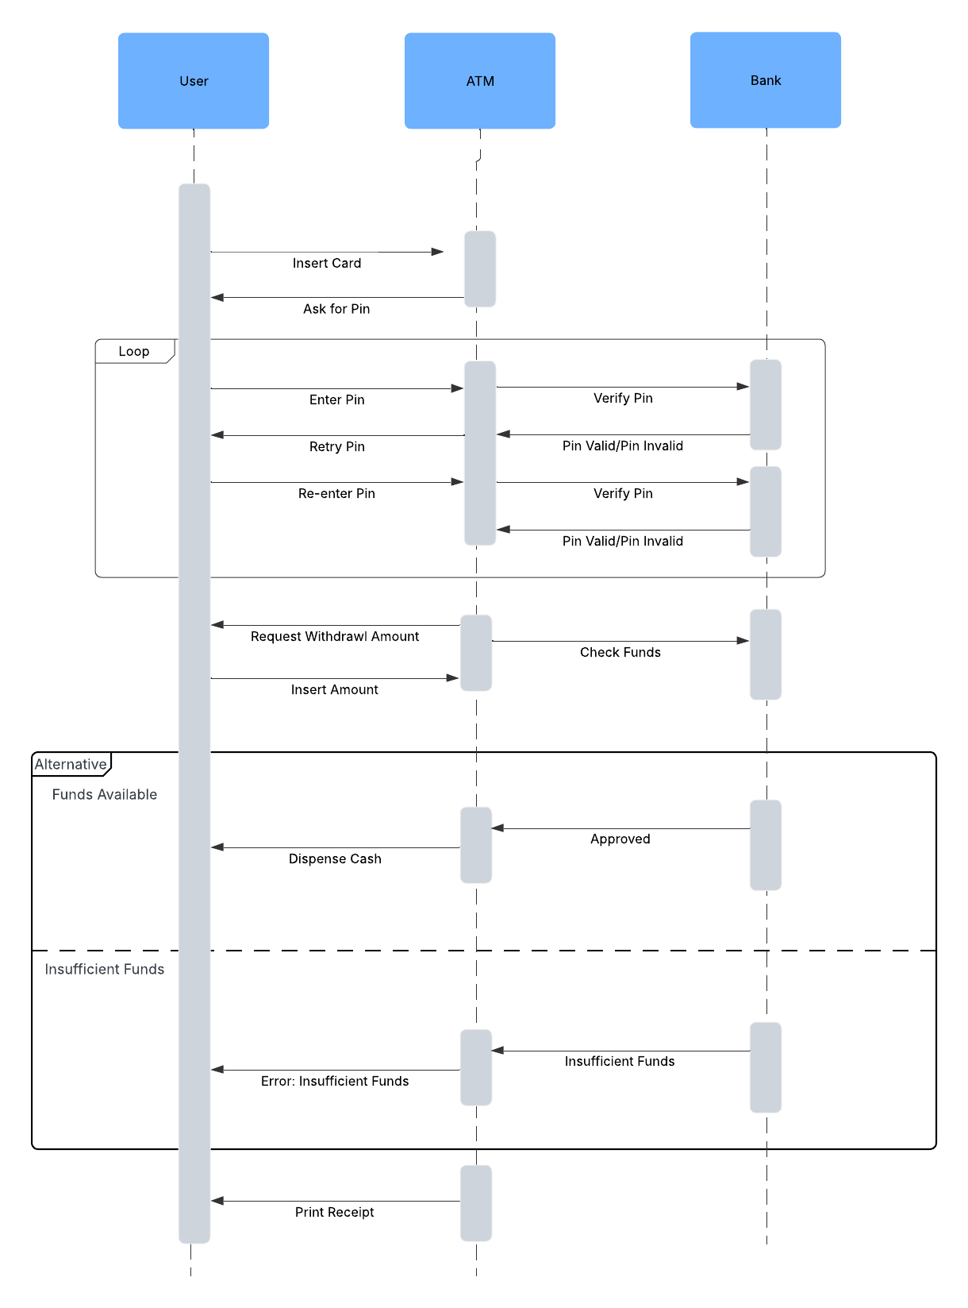

UML Class Diagram
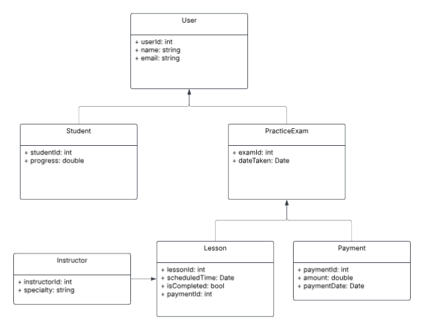

Technical Requirements

Hardware Requirements

- A stable internet connection for both end-users and internal staff

- Web server (cloud-based, such as AWS, Azure, or Google Cloud) to host the application

- Secure database server to store user profiles, lesson reservations, test results, and activity logs

Software Requirements

- Web application framework (e.g., Django, Laravel, or Node.js) to develop the system

- Relational database system (e.g., MySQL or PostgreSQL) for structured data storage

- Front-end technologies (HTML, CSS, JavaScript) for the user interface

- Excel-compatible export functionality for report downloads

Tools and Infrastructure

- Cloud hosting platform for scalability and remote accessibility

- Lucidchart or another CASE tool for ongoing diagramming and system modeling

- Authentication and role-based access system to manage permissions (admin, secretary, IT officer, customer)

- Email/notification system to alert users of DMV updates or password resets

- Audit logging module to track who made or modified reservations

Nonfunctional Requirements
- Security: All data must be encrypted in transit (HTTPS) and rest. Role-based access ensures proper permission. Passwords are resettable but not recoverable.

- Availability: The system must be available 99.9% of the time, with proper backup and recovery protocols.

- Usability: The interface should be easy to navigate for both customers and staff, with the minimal technical support required.

- Scalability: The system should support future expansion, including more packages or additional users.

